Netherlands Website Project

Team members:

Adaam Ammantoola

Simon Cliff

Daniel Alfonso

*Our website will have general information about Netherlands, we agree on this country and are currently researching some important information for our website.*

*Our meetings have taken place at school and online using the collaboration tool Discord, where we have created a channel that allow us to share documents, broadcast screen and send files. We have not been able to advance as much as expected, but we have rescheduled meetings to get up to date by the weekend.*

**Index.html preview**

We have had some issues trying to get the responsiveness in layout with bootstrap, but we are planning to meet on Friday to correct these issues and get the site running. And for the next week we will have two more in person meetings to complete all the web pages.

We have worked online through discord, to set up fix the index page, which still need some adjustments, we would submit the attached file.

We expect to add all components required and the content by December 16th.

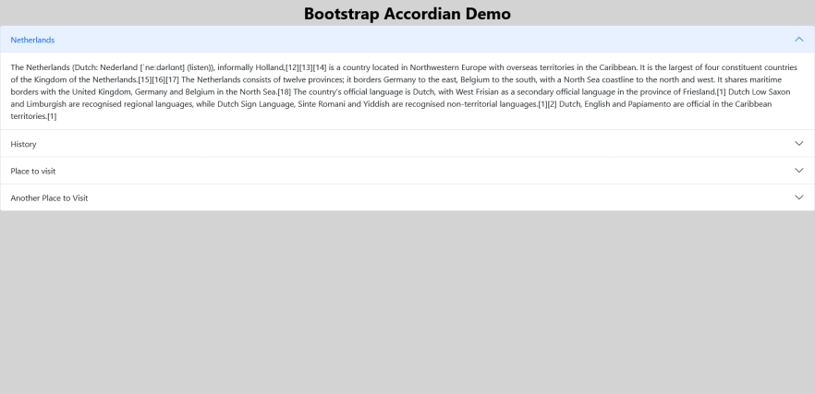

**Groupwork**

We did our layout mock up design using Balsamic online. The colors and fonts a limited in this tool, so we will make some changes applying Bootstrap 5.0

